***Exception Handling!***

Q1. Write a Program for taking name or age and throw a User defined exception if enter age is negative.

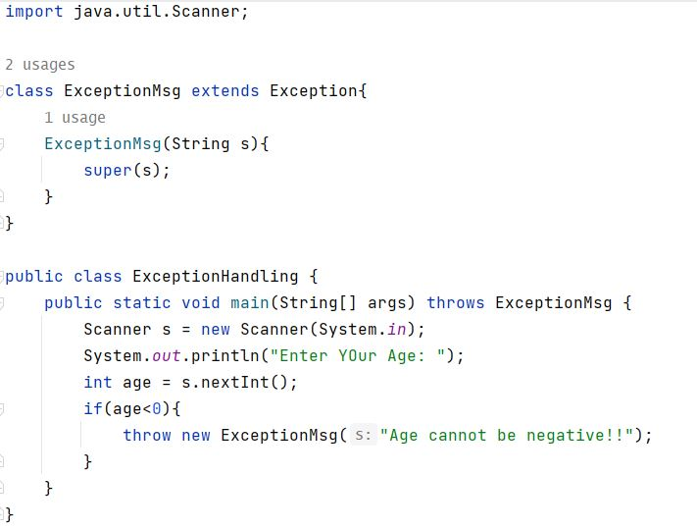

Output:

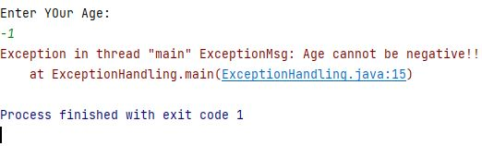

Q2. Write a Program to accept from user throw authentication failure exception if password is incorrect.

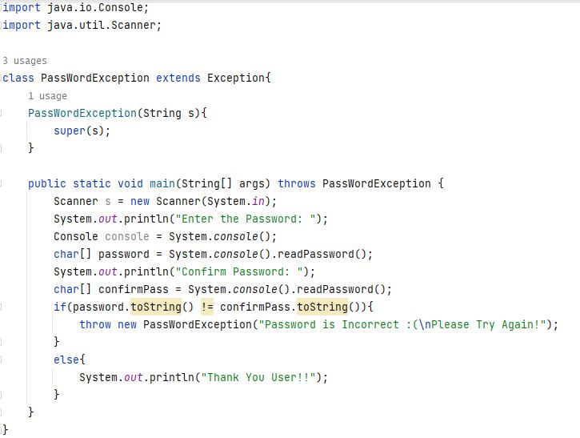

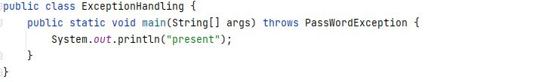

Output:

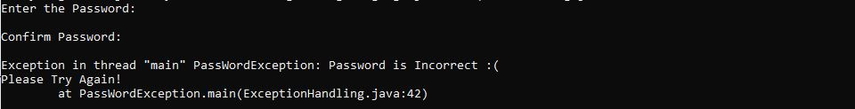

Q3. Write a Program throw User Defined exception string mismatch exception.

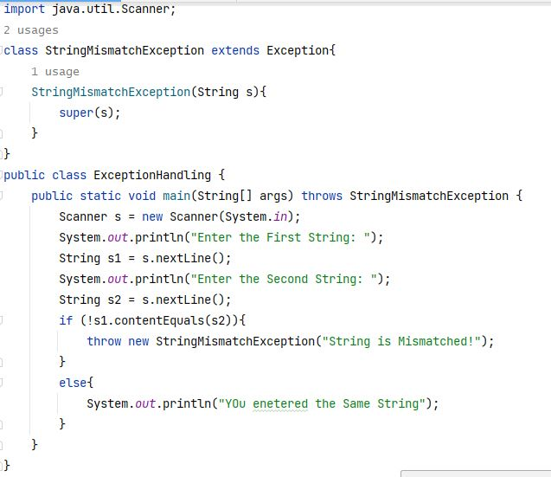

Output:

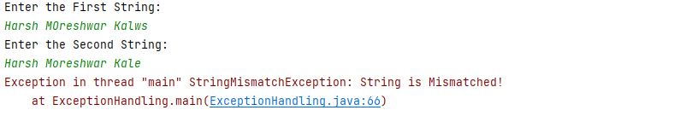

Q4. Write a Program to throw User defined exception as “Invalid Age”. If age entered by user is less than 18.

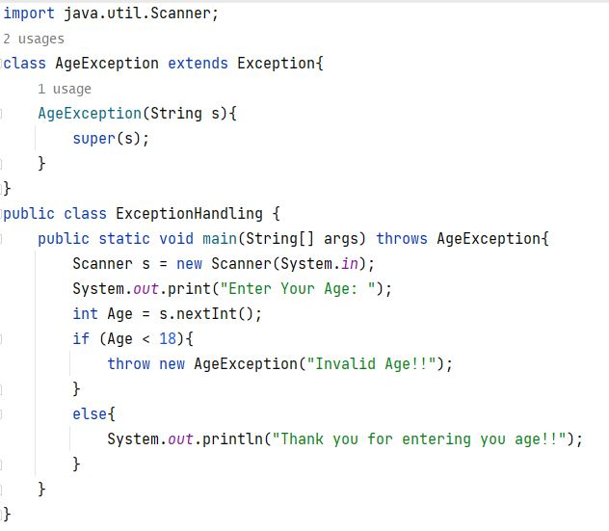

Output:

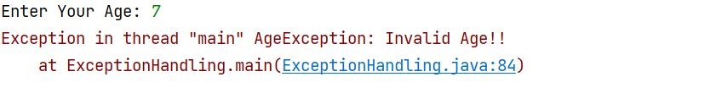

Q5. Define Exception NO match Exception that is throw when string is not equal to MSBTE.

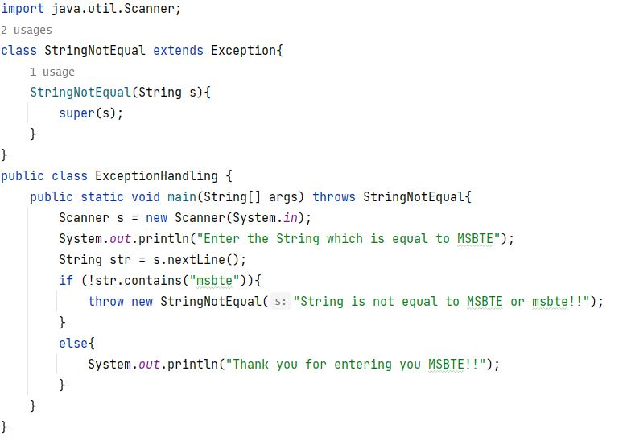

Output:

